Events
https://www.udemy.com/course/modern-javascript-from-the-beginning/learn/lecture/37192166#questions/19875708
84 Event Listeners
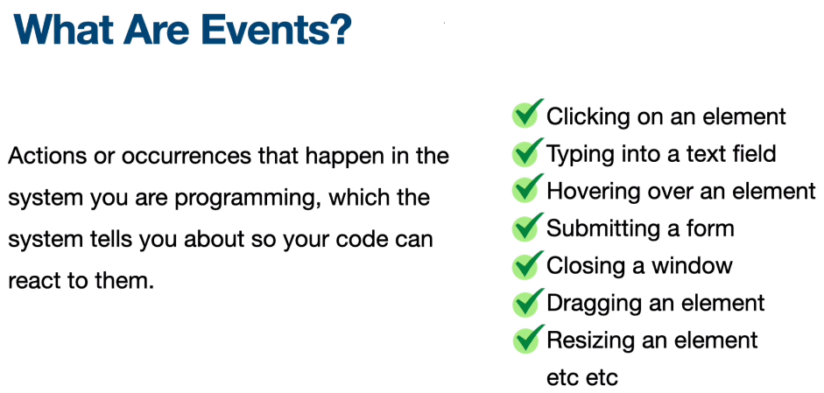

Events can be listened to
They can be added inline in the HTML but this is not recommend as it poses security risks 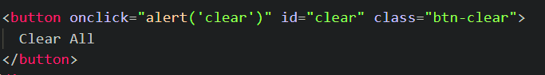
Ways to write in JS
const clearBtn = document.querySelector("#clear");
// the function to run on the event
function onClear() {
alert("clear");
}
clearBtn.onclick = onClear;
/// another way to write
clearBtn.onclick = function () {
alert("cleared");
};
/// ES 6 way to write
clearBtn.onclick = () => alert("clear");

addEventListener() method of the EventTarget interface sets up a function that will be called whenever the specified event is delivered to the target. Common targets are Element, or its children, Document, and Window, but the target may be any object that supports events (such as IDBRequest).
Note: The addEventListener() method is the recommended way to register an event listener. The benefits are as follows:
- It allows adding more than one handler for an event. (so you can do a click and do more than one thing) This is particularly useful for libraries, JavaScript modules, or any other kind of code that needs to work well with other libraries or extensions.
- In contrast to using an onXYZ property, it gives you finer-grained control of the phase when the listener is activated (capturing vs. bubbling).
- It works on any event target, not just HTML or SVG elements.

removeEventListener() method of the EventTarget interface removes an event listener previously registered with EventTarget.addEventListener() from the target. The event listener to be removed is identified using a combination of the event type, the event listener function itself, and various optional options that may affect the matching process; see Matching event listeners for removal. Do not need to use it every time the addEventListener is used, where you do need use it is when you have an element that you are removing from the DOM
.click() The HTMLElement.click() method simulates a mouse click on an element. When click() is used with supported elements (such as an <input>), it fires the element's click event. This event then bubbles up to elements higher in the document tree (or event chain) and fires their click events.
85 Mouse Events – More than just the click – note lower case
click
dblclick
contextmenu - aka right click
mouseup
mousedown
wheel
mouseover
mouseout
dragstart
drag
dragend
86 Mouse Event Object – Pointer Events mouse and other input devices, such as pen/stylus and touch surfaces, DOM events that are fired for a pointing device. The pointer is a hardware-agnostic device that can target a specific set of screen coordinates. for scenarios when device-specific handling is desired, pointer events defines a pointerType property to inspect the device type which produced the event. Additionally, a pointer event contains the usual properties present in mouse events (client coordinates, target element, button states, etc.) in addition to new properties for other forms of input: pressure, contact geometry, tilt, etc. In fact, the PointerEvent interface inherits all of the MouseEvent properties, thus facilitating the migration of content from mouse events to pointer events.
Many any different – some of the big ones
- `target` - The element that triggered the event
- `currentTarget` - The element that the event listener is attached to (These are the same in this case
- `type` - The type of event that was triggered
- `timeStamp` - The time that the event was triggered
- `clientX` - The x position of the mouse click relative to the window
- `clientY` - The y position of the mouse click relative to the window
- `offsetX` - The x position of the mouse click relative to the element
- `offsetY` - The y position of the mouse click relative to the element
- `pageX` - The x position of the mouse click relative to the page
- `pageY` - The y position of the mouse click relative to the page
- `screenX` - The x position of the mouse click relative to the screen
- `screenY` - The y position of the mouse click relative to the screen
e.preventDefault() method prevents the default behavior – used a lot with forms
87-Keyboard events and key properties - Keyboard events are only generated by <input>, <textarea>, <summary> and anything with the contentEditable or tabindex attribute. If not caught, they bubble up the DOM tree until they reach Document.
keypress- deprecated do not use
keydown - The keydown event is fired when a key is pressed. Unlike the deprecated keypress event, the keydown event is fired for all keys, regardless of whether they produce a character value. The keydown and keyup events provide a code indicating which key is pressed, while keypress indicates which character was entered. For example, a lowercase "a" will be reported as 65 by keydown and keyup, but as 97 by keypress. An uppercase "A" is reported as 65 by all events.
keyup - The keyup event is fired when a key is released.
e.repeat - checks if key is being held down.
e.shiftKey,e.ctrlKey, e.altKey are also helpful
88 Keycode project / challenge
createTextNode() Creates a new Text node. This method can be used to escape HTML characters
89- Input Events The input event fires when the value of an <input>, <select>, or <textarea> element has been changed as a direct result of a user action (such as typing in a textbox or checking a checkbox). The input event is fired every time the value of the element changes. This is unlike the change event, which only fires when the value is committed, such as by pressing the enter key or selecting a value from a list of options. Note that the input event is not fired when JavaScript changes an element's value programmatically.
Syntax
addEventListener("input", (event) => {});
oninput = (event) => {};
input – can use e.target.value to get what is being typed into the the text box.
checked
focus
blur
90 – Form Submission and Form Data Object – back end js can put a form action in the form , for front end adding to JS file
submit The submit event fires when a <form> is submitted. Note that the submit event fires on the <form> element itself, and not on any <button> or <input type="submit"> inside it. However, the SubmitEvent which is sent to indicate the form's submit action has been triggered includes a submitter property, which is the button that was invoked to trigger the submit request.
The submit event fires when:
- the user clicks a submit button,
- the user presses Enter while editing a field (e.g. <input type="text">) in a form,
- a script calls the form.requestSubmit() method
Syntax
Use the event name in methods like addEventListener(), or set an event handler property.
addEventListener("submit", (event) => {
});

onsubmit = (event) => {
};
if there is no action on the form that would come into play with a back end the submit action submits to the same page – so need to prevent default
submit event object :
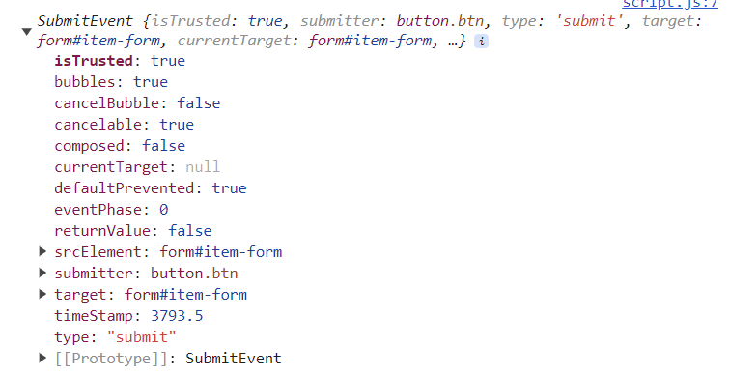
It is important to do form validation on the front end prior to the event and on the server side back end
FormData object - The FormData interface provides a way to construct a set of key/value pairs representing form fields and their values, which can be sent using the fetch(), XMLHttpRequest.send() or navigator.sendBeacon() methods. It uses the same format a form would use if the encoding type were set to "multipart/form-data".
You can also pass it directly to the URLSearchParams constructor if you want to generate query parameters in the way a <form> would do if it were using simple GET submission.
An object implementing FormData can directly be used in a for...of structure, instead of entries(): for (const p of myFormData) is equivalent to for (const p of myFormData.entries()).
Constructor
FormData()
Instance Methods
.apppend() , .delete(), .entires(), .get(), .getAll(), .has(), .keys(),.set(), .values()
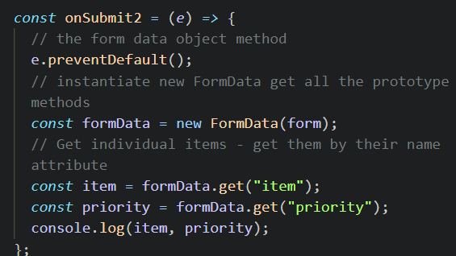

.entries() static method returns an array of a given object's own enumerable string-keyed property key-value pairs.
Syntax –
Object.entries(obj)
91- Event Bubbling
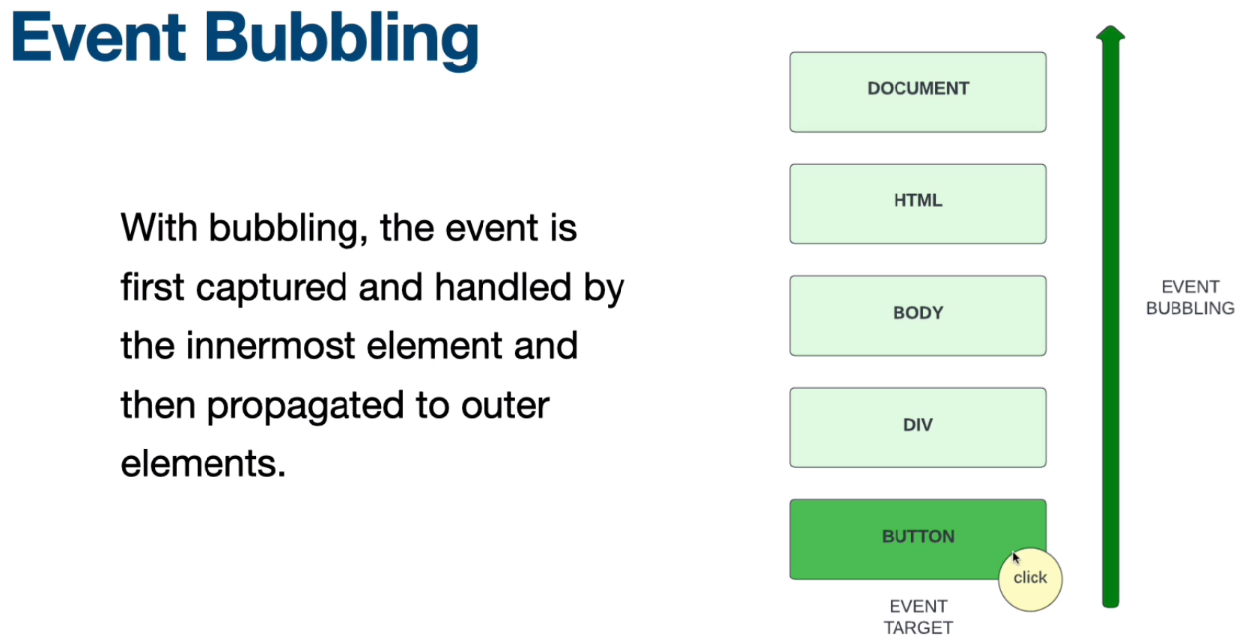
stopPropagation() method of the Event interface prevents further propagation of the current event in the capturing and bubbling phases. It does not, however, prevent any default behaviors from occurring; for instance, clicks on links are still processed. If you want to stop those behaviors, see the preventDefault() method. It also does not prevent propagation to other event-handlers of the current element. If you want to stop those, see stopImmediatePropagation().
Syntax
event.stopPropagation()
92 Event Delegation and Multiple Elements – event handling pattern , can add the event listener onto the parent and then target
e.target - what is clicked on
e.currentTarget - what the event listener is on
The tagName read-only property of the Element interface returns the tag name of the element on which it's called.
More on event delegation - https://www.freecodecamp.org/news/event-delegation-javascript/
93 Window Events -
Window: load event -The load event is fired when the whole page has loaded, including all dependent resources such as stylesheets, scripts, iframes, and images. This is in contrast to DOMContentLoaded, which is fired as soon as the page DOM has been loaded, without waiting for resources to finish loading.
Document: DOMContentLoaded event The DOMContentLoaded event fires when the HTML document has been completely parsed, and all deferred scripts (<script defer src="…"> and <script type="module">) have downloaded and executed. It doesn't wait for other things like images, subframes, and async scripts to finish loading.
Window: resize event -The resize event fires when the document view (window) has been resized.
Document: scroll event The scroll event fires when the document view has been scrolled. To detect when scrolling has completed, see the Document: scrollend event. For element scrolling, see Element: scroll event.
Element: focus event -The focus event fires when an element has received focus. The event does not bubble, but the related focusin event that follows does bubble.the opposite of focus is the blur event, which fires when the element has lost focus.
Element: blur event -The blur event fires when an element has lost focus. The event does not bubble, but the related focusout event that follows does bubble. An element will lose focus if another element is selected. An element will also lose focus if a style that does not allow focus is applied, such as hidden, or if the element is removed from the document — in both of these cases focus moves to the body element (viewport). Note however that blur is not fired when a focused element is removed from the document.
The opposite of blur is the focus event, which fires when the element has received focus.

